Shopify – ESG Global Fulfillment (Version 1.0)

Merchant Integration Checklist

August 2016

*Please review this whole document prior to integration*

Contents

APP PRE-INSTALLATION 2
Products (and ESG Dispatcher Portal) 2
Settings – Checkout 3
Online Store – Themes (amend language text for the Checkout & System) 4
APP CO-INSTALLATION 6
Settings – Payment 6
Settings – Shipping 6
APP POST-INSTALLATION 7
Switching from an existing 3PL? 7

CHECKLIST
APP PRE-INSTALLATION
15 checkpoints

APP CO-INSTALLATION
2 checkpoints

APP POST-INSTALLATION
3 checkpoints, 4 key questions

APP PRE-INSTALLATION

Products (and ESG Dispatcher Portal)

☐ Ensure all Inventory products have SKU (Stock Keeping Unit) data entered
(https://your-shop-name.myshopify.com/admin/products/new)

New Product add in Shopify store
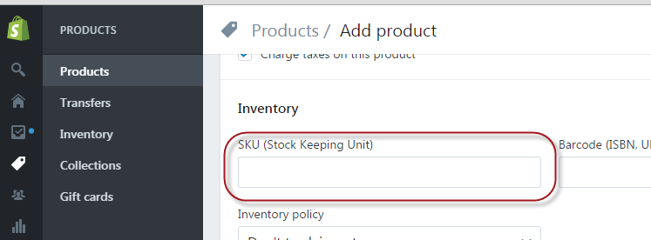

Existing Product in Shopify store
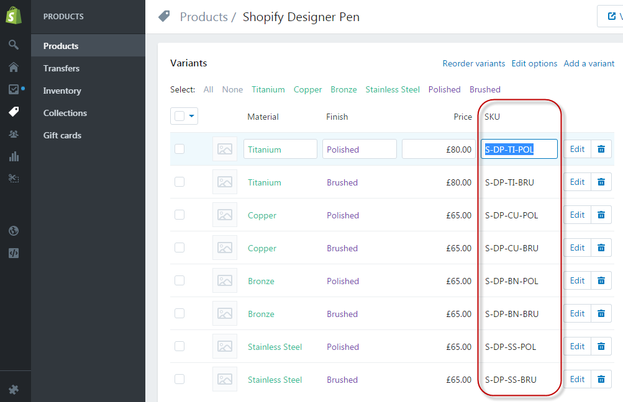

☐ If only selected products are to be fulfilled by ESG, create a custom fulfillment service with a unique name that can be designated for use by ESG Global Fulfillment (https://your-shop-name.myshopify.com/admin/settings/shipping/fulfillment_dropshipping); the name created must contain only alphanumerics and spaces; skip this step if all products are to be shipped are to be fulfilled by ESG.

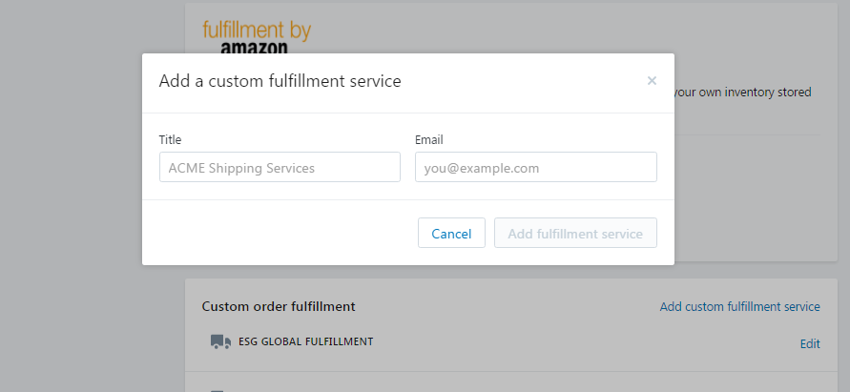

☐ For the selected products to be fulfilled by ESG, ensure edits in Shipping attributes for all corresponding products/variants are made to select the correct fulfillment service:

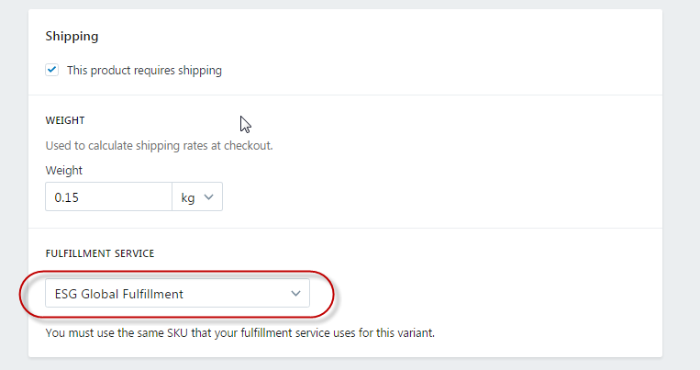

☐ Create matching products in ESG Dispatcher Management portal
(http://merchant.eservicesgroup.com/marketing/product_merchant/store)

Settings – Checkout

Ensure Form options (https://your-shop-name.myshopify.com/admin/settings/checkout)
are set with the following:

☐ (1) Full name to “Require first and last name”;
☐ (2) Company name to be “Optional”;
☐ (3) Address line 2 to be “Optional”;
☐ (4) Phone number to be “Required”.

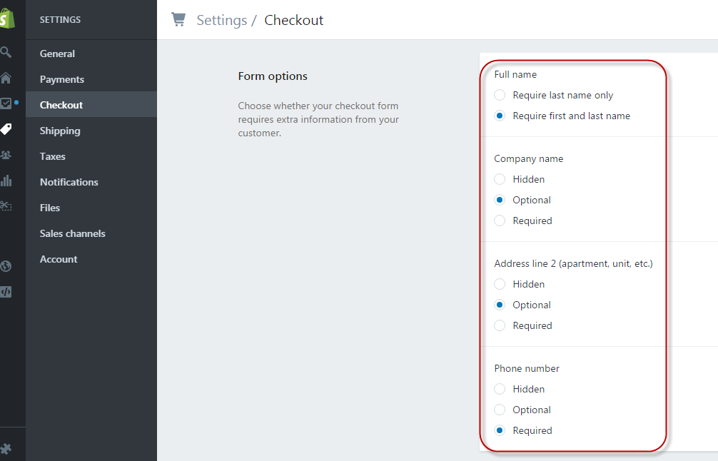

Ensure Order processing is set with the following:
☐ After an order has been paid to be set to “Do not automatically fulfill any of the order’s line items.

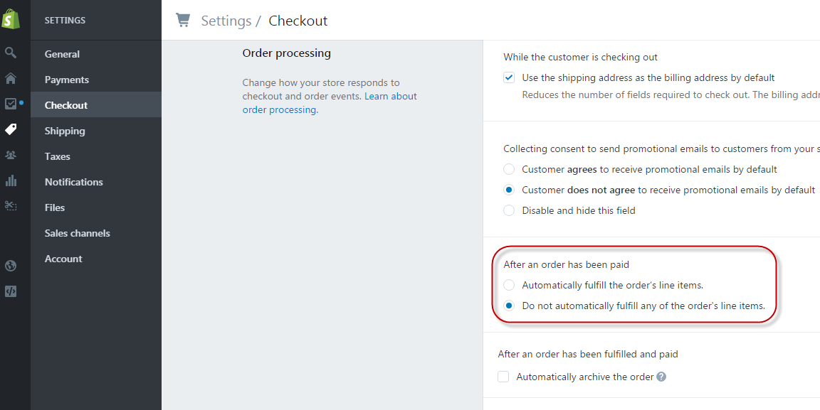

Online Store – Themes (amend language text for the Checkout & System)

Go to https://your-shop-name.myshopify.com/admin/themes, and choose to “Edit language”:

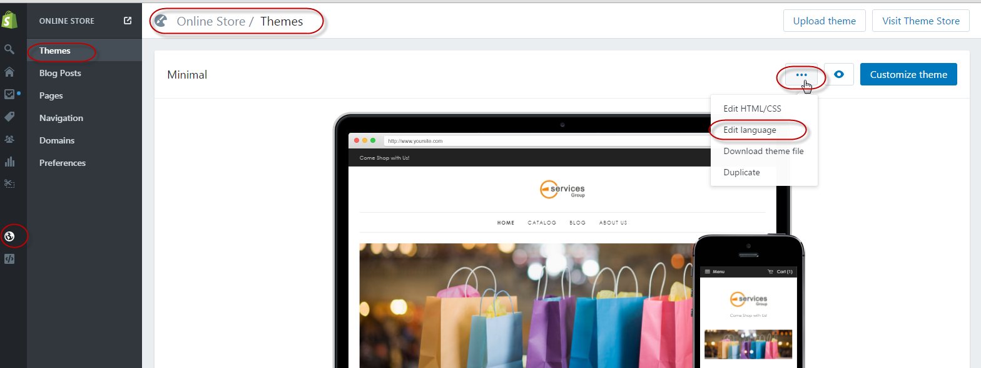

Then select the “Checkout & system” tab:

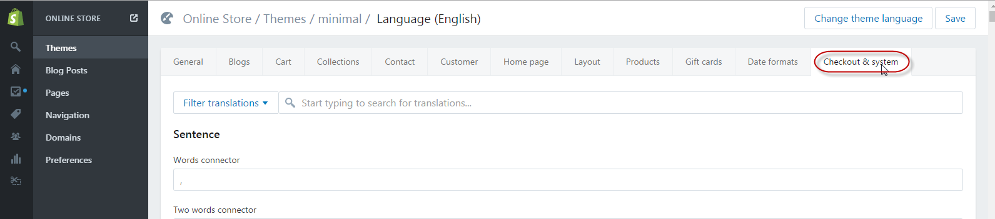

Once in the “Checkout & system” tab, scroll down until you reach the “Checkout contact” section”:

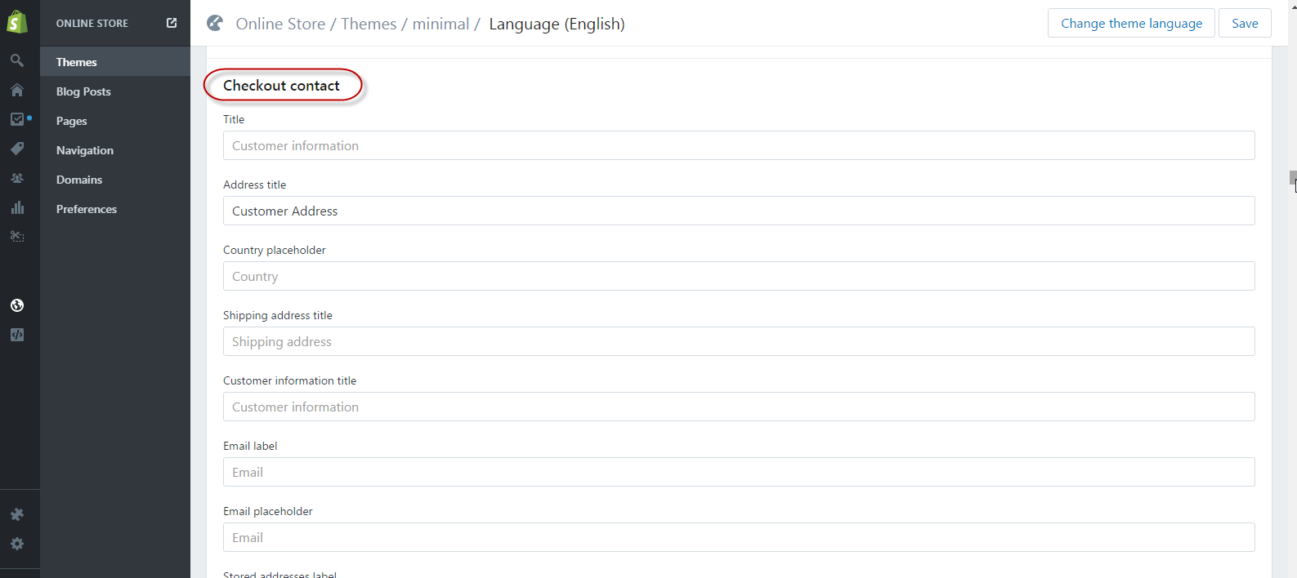

Within the “Checkout contact” section”, there are field names; for each field name, enter the corresponding help text:
(the following text changes in conjunction with the Checkout settings will help minimize manual work and provide the delivery information in the format required by our international couriers)

☐ (1) First name label enter “First name (max.15 characters)”;
☐ (2) Last name label enter “Last name (max.15 characters)”;
☐ (3) Optional company label enter “Company (optional; max. 35 characters)”;
☐ (4) Address1 label enter “Address (max. 35 characters; / - # , . \ and short forms allowed)”.
☐ (5) Optional address2 label enter “Apt, suite (max. 35 characters)”;
☐ (6) Phone label enter “Phone Number (max. 15 characters)”.

APP CO-INSTALLATION

Settings – Payment

☐ Ensure Payment authorization (https://your-shop-name.myshopify.com/admin/settings/payments) is set to “Automatically capture payment for orders”
- this allows order to automatically flow to ESG systems, ignore if you wish to manually check orders before sending to ESG.

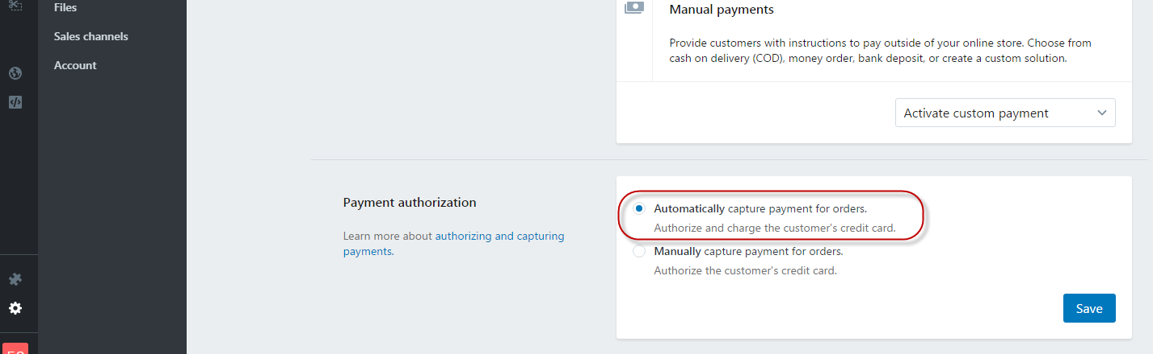

Settings – Shipping

☐ Check if Zones and rates setup (https://your-shop-name.myshopify.com/admin/settings/shipping) needs updating; ESG will charge according to quotation, not what is paid by the customer

APP POST-INSTALLATION

Switching from an existing 3PL?

Need to ensure all store orders that aren’t to be handled by ESG are resolved (cancelled/refunded or fulfilled) – app will export any order that is paid and not fulfilled yet.
☐ If merchant is working to run down the inventory at pre-existing 3PL, 3PL may run out of stock before 3PL integration is terminated - in this case, merchant will have to simply cancel those open orders with the 3PL; if for some reason those open orders are marked as fulfilled, merchant will have to create the order manually for our side. Orders that have been passed to ESG can be seen in the ESG app or from ESG Dispatcher Portal reports – merchant can monitor themselves or ESG can help to see what the first orders coming through to ESG are.
☐ If merchant finds that there is still inventory and open orders at the pre-existing 3PL after terminating the integration with the 3PL, again merchant can monitor themselves or ESG can help to see what the orders coming through to ESG are, and cancel those ‘surplus’ orders on ESG system.
☐ Strongly recommend that the switch over occurs after ESG’s daily fulfillment processing cut off time (6am HKT), and that the cross checks are carried out within the same day.

Key Questions:
☐ If payments are still to be captured, are those orders processed for fulfillment with the pre-existing 3PL?
☐ If payments are already captured, are those orders processed for fulfillment with the pre-existing 3PL?
☐ Are orders automatically marked as fulfilled?
☐ If not automatically marked as fulfilled, at what point in the process are orders marked as fulfilled?

